**Git**

1. git –version

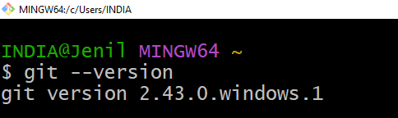

2. git config –global user.name “Jenil Ambawala”

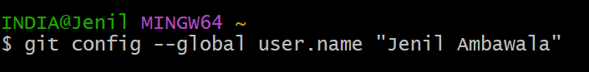

3. git config –global user.email “jenilambawala25@gmail.com”



4. git config –list

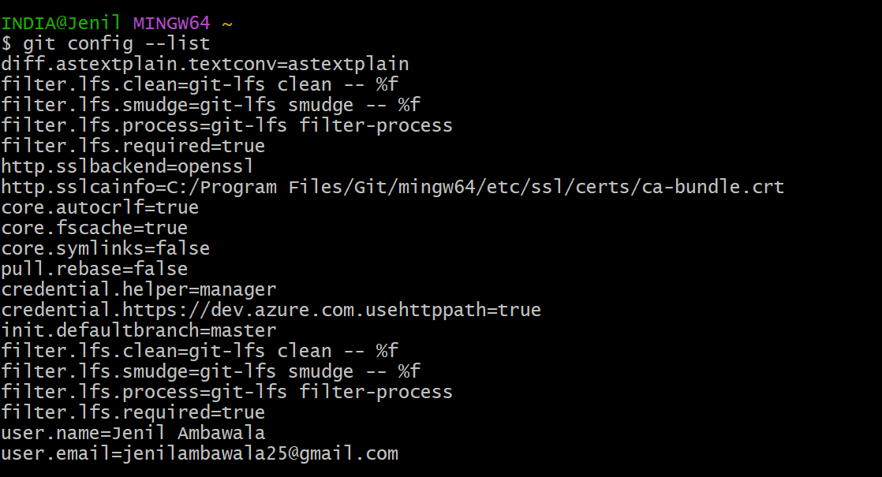

5. **Create Project :** mkdir mscca-git

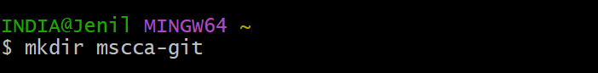

6. **Select project folder path :** cd mscca-git

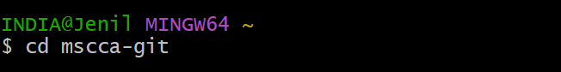

7. **Present working directory** **:** pwd

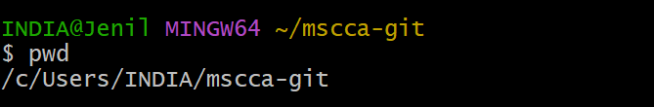

8. git init

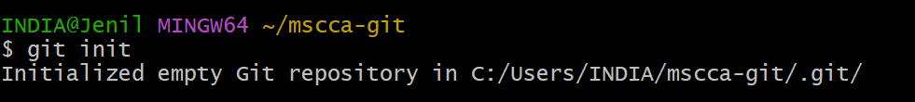

9. **Open Path :** C:\Users\INDIA\mscca-git => View => Hidden items option on

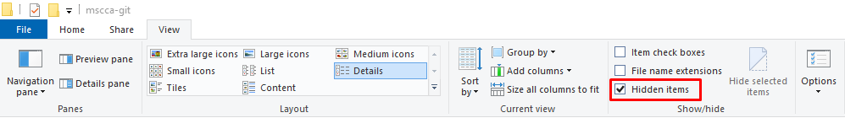

10. Three File Manual File Create (index.html, custome.css, custome.js)

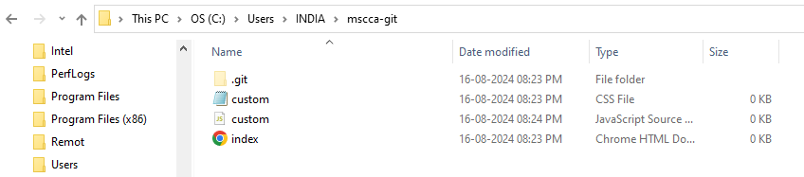

11. **Check Status :** git status

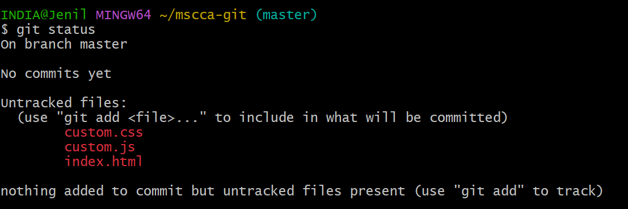

12. git add –a / git add .

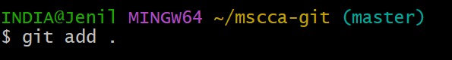

13. **Check Status :** git status

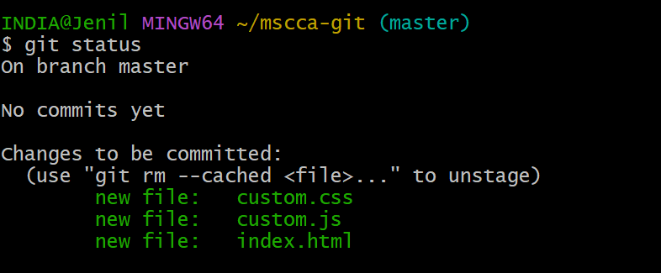

14. git commit -m “Add Three Files”

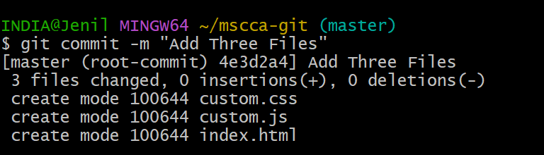

15. Check Status : git status

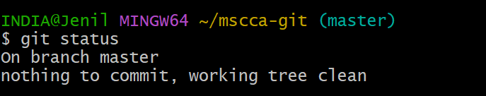

16. Manual Modified All Files and Check Status

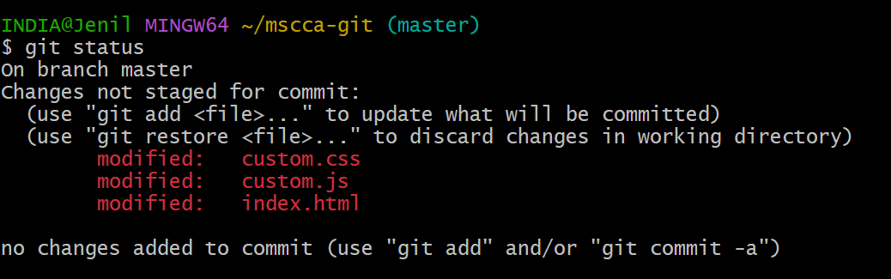

17. git add –a / git add .



18. **Check Status :** git status

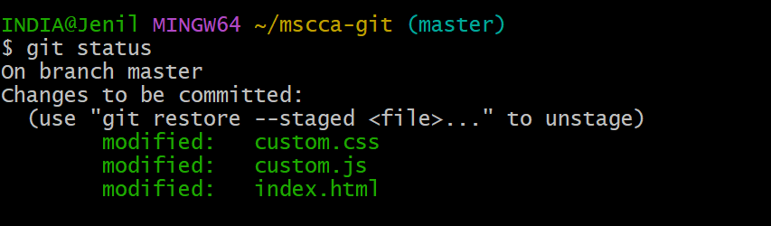

19. git commit -m “Three Files Modified”

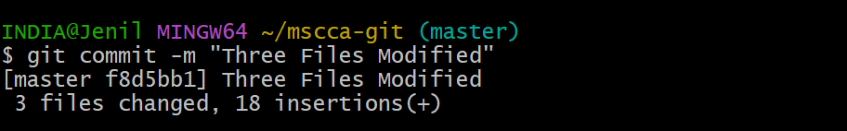

20. **Check Status :** git status

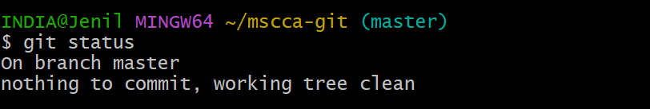

20. **Check Status :** git log

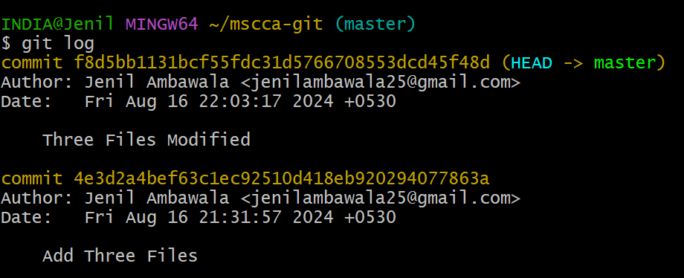

21. git –online

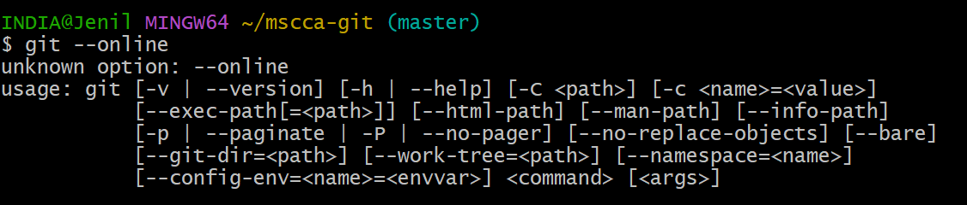

22. git log –stat

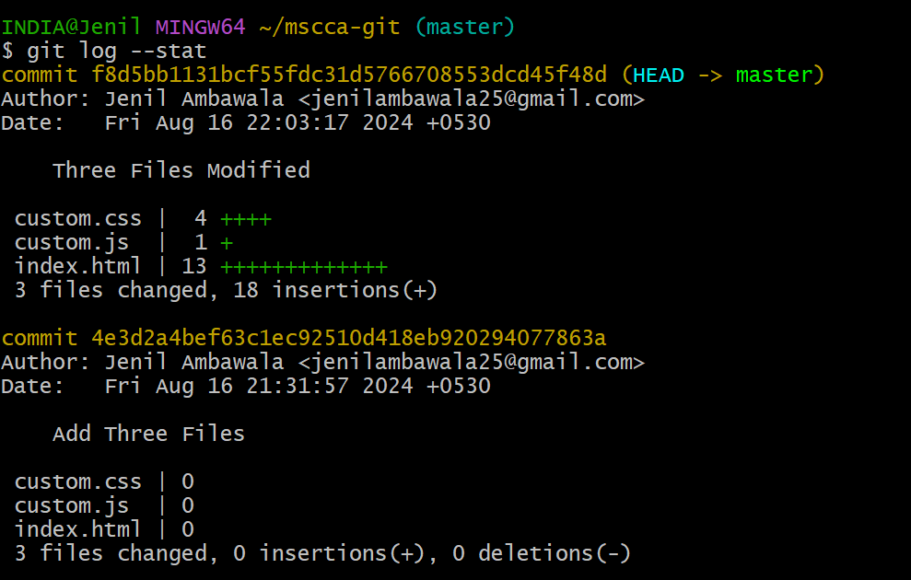

23. git log –patch

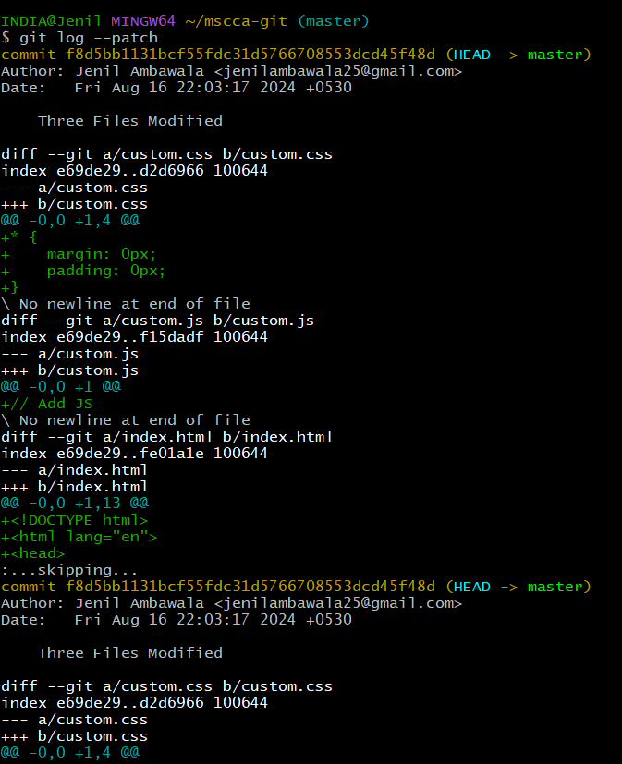

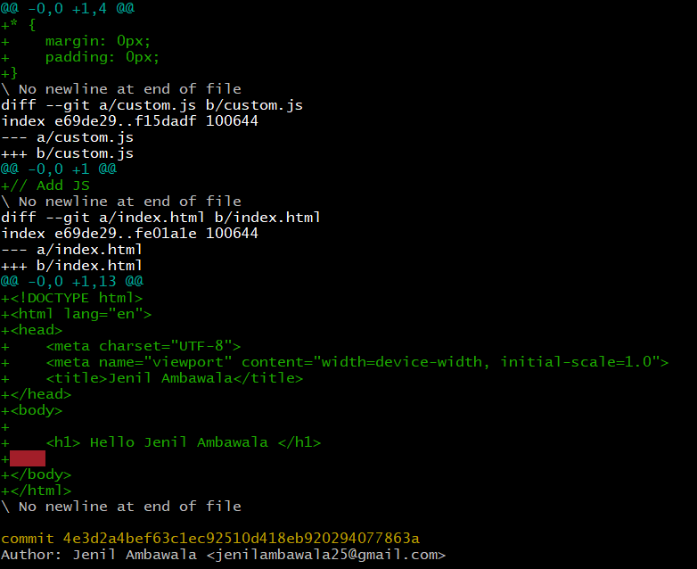

24. **Command Line ma Enter thava mate :** ewq

25. git log –graph

